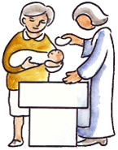
Christenings in Harnham
We are delighted you’re thinking of a Christening in the Parish of Harnham. Thank you for choosing our Church.

This leaflet will hopefully answer some of the initial questions you may have and assist you with completing the enclosed Christening form. You will have an opportunity to meet with the Vicar taking the Christening Service, who will talk you through the service and answer any questions you may have, so you know what to expect and understand what is happening.
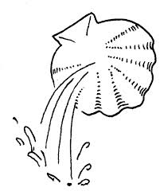
1. What is the difference between a Baptism and a Christening?
There is no difference between a Christening Service and a Baptism Service. Some churches will use the word 'baptism' and some the word 'christening'. To ‘christen’ means to be clothed with Christ. Christ is a special name used for Jesus. That is why some people choose to use a special gown for their baby at the service. The word 'baptism' means 'to be immersed in water'. In this leaflet we will use the word christen.

2. Can anyone have a Christening Service?
Yes, so long as they have not already been Christened. The Church of England welcomes all babies, children and adults for Christening(s) - whatever shape that family takes. You do not have to be married to ask for a Christening for your child. You do not have to be an active churchgoer - as parents, you do not even have to have been Christened yourselves. Everyone is welcome.

3. How much does a Christening Service cost?
We ask that you make a donation to our church funds of £60 to cover the cost of lighting, heating and administration. The running costs of the Church in Harnham are £1500 per week and we are a charity. If you are a tax payer please use the enclosed Gift Aid envelope so that we can receive a further 28% back. Please bring the envelope with you to the Christening. (Any cheques should be made out to ‘Harnham’ PCC.)

4. Where can we hold the Christening?
You can have your baby Christened at either St.George’s Church or All Saints Church. It is usually held as part of the main Sunday service, but occasionally numbers or special family circumstances mean this is not possible. So we would make separate arrangements, usually following on from a Sunday service.
If you live outside the Parish and are having the Christening in Harnham (as this is where you grew up or where you were married) you will need to talk to the Vicar at your local church and seek his/her permission on the Christening form in order for the service to take place here.

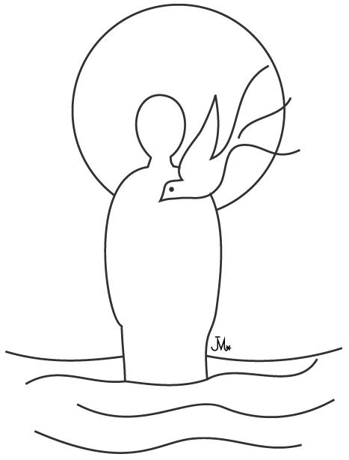
5. Does it matter how old my child is?
No. A Christening can take place at any age. Jesus was 30 when he was baptised in the River Jordan. So there is no upper age limit and after about the age of seven your child may be able to make the promises for themselves. The Vicar will talk to you about this.

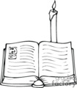
6. What happens in the service?
Godparents and parents will make promises on behalf of the baby, and prayers will be offered for the baby and the family.
The baby will be signed with the cross using a special oil. Water will be blessed and poured on the baby's head.
A candle, Christening card and Godparent cards will be given as a gift from the Church.
7. What exactly is a Christening?
God loves your child. Christening marks the beginning of your child’s journey with God which continues for the rest of their life. So the step of Christening is a response to God's love. You are saying ‘Yes I want to celebrate the love I have for my child and for my child to know the love of God.’ It is a celebration, a time to come together with family and friends; remembering that your child is loved by God, is part of a wider community, and has a place with God's people.

8. Why do you need parent’s full names and occupations?
Your child’s Christening is recorded in the Church registers and we like to do that properly! We also like to make sure that we have the full and correct name for your child to include on all records as often families have special spellings.

9. Godparents.
Godparents are some of the most important people at the Christening.
Godparents are not the people who will care for your child should anything happen to you. Arrangements for this would normally be made by a Will. Rather, they should be people who will be there for your child and help them think about the bigger questions in life - questions of love, hope and faith.
It is usual for the child to have three godparents, two of the same sex and at least one of the opposite sex. Parents may be godparents for their own children, providing they have at least one other godparent.
Godparents must be baptised and old enough to make some serious promises on behalf of the child.

We hope your child’s Christening will be a wonderful and memorable occasion and that it will mark the beginning of a long and happy relationship with God and association with our Church. Should you have any further questions, or need assistance filling in the Christening form please contact us. (The details are below).

Parish Office, The Church Hall, Lower Street, Harnham, SP2 8EY
Email: harnhamparish@btinternet.com Telephone or Text: 07925 108856

Revd. Becky Roberts reverendbecky@gmail.com 01722 333564

