HYMN REFLECTION by Malcolm Sturgess

What are hymns for? My personal view is that Readings, Intercessions, Sermon and Hymns should all relate to a central theme, usually based on the Gospel. Readings, Sermon and Intercessions are given by the priest or somebody specially appointed to the job. Hymns are the congregation's chance to take an active part in the service, to help them understand the theme, and to enable them to feel, "Yes, we are part of this".

So THE OBVIOUS HYMN for Easter 2, based, as we said, on the Gospel, is Ye sons and daughters, originally O filii et filiae. It includes the obligatory Easter alleluias. It is easy to sing. It is long, so ideal as an Offertory Hymn. It articulates the doubts which many of us have. So why don't we sing it? It is an ancient hymn,originally written in Latin by a French author, so there are differing translations. Here are verses 4 - 8 from the old English Hymnal which many of us used in our youth:

That night the Apostles met in fear;
Amidst the came their Lord most dear,
And said, "Peace be unto you here!" Alleluia.

When Thomas afterwards had heard
That Jesus had fulfilled his word,
He doubted if it were the Lord. Alleluia.

"Thomas, behold my side," said he,
"My hand, my feet, my body, see,
And doubt not, but believe in me". Alleluia.

No longer Thomas then denied.
He saw the feet, the hands, the side.
"Thou art my Lord and God, " he cried. Alleluia.

Blessed are they that have not seen,
And yet whose faith hath constant been;
In life eternal they shall reign, Alleluia.

Reflections for Easter 2
Readings: Acts 2 v 14a, 22-32 and John 20 v 19-31

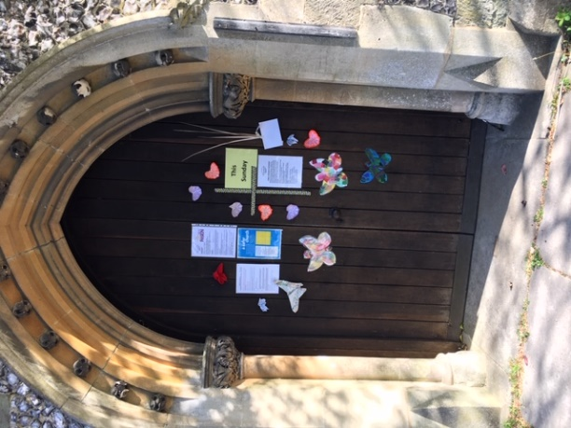
BEHIND LOCKED DOORS....
Lord, come alive within my experience,
within my sorrows and disappointments and doubts,
within the ordinary movements of my life.
Come alive as the peace and joy and assurance that is
stronger than the locked doors within, with which we
try to shut out life.
Come alive as the peace and joy and assurance that
nothing in life or death can kill. AMEN.

EASTER COMMUNION WITH OUR RISEN LORD
Rev.David Callard reflects:

One Easter Communion I remember clearly, though it took place 55 years ago. As a brand new Curate my Vicar asked me to go on Easter Monday to a bedbound lady, who lived with her daughter's young family. Her two little grandchildren, anxious to be part of the experience, sat on the bedroom floor, making a congregation of four. With great reverence, when I shared bread and wine with Granny, the elder child broke a piece of her Easter egg and gave it to her little brother. "And He was made known to them in the breaking of the bread."
In the U.S.A. they refer to the housebound as "Shut Ins," a realistic, though unpalatable phrase, I have always felt. All of us are sharing that experience at first hand, during these weeks of Lock Down within our homes. And that is how Jesus' closest friends must have felt when Jesus, their Lord and Master, was tried and executed on the Cross. "Will we be the next to die?" So they stayed "behind locked doors for fear... as this Sunday's Gospel Reading says.
But when a Visitor appeared, who was it ---but Jesus, their Risen Lord ---and his message rings down the centuries to us, behind our locked doors,----"Peace be with you! Receive the Holy Spirit!" Their worst experience was turned into an experience of unbelievable Peace and Blessing. Finally Thomas, the Doubter, found his own moment of transformation when Jesus made himself known to him in his own personal Resurrection Appearance. And Thomas became Thomas the Resurrection Believer ----"My Lord and my God!" he cried out.
I have found my own locked in weeks to be blessed, again and again, Blessed by neighbourly kindnesses and human messages of friendship and encouragement. Unexpected people have been wonderful and many blessings have flowed. I hope that you have also shared that experience yourself.
Our Lock Down has been played out against a background of glorious spring sunshine, and a dazzling outburst of nature exploding in blossom and flowers and spring glory. Birds sing their anthems of joy. Butter-flies in profusion are flitting around my garden --- six different species I counted, as I sat outside reading on Good Friday afternoon. And Butterflies have always been seen as symbols of Resurrection. "Thank you, Lord, for all your blessings to us!"
Those wonderful stories at the end of the four Gospels --- Jesus's Resurrection Appearances---have been described as "The Journey from Doubt to Faith." They are my favourite passages in the whole of the Bible. Do take time this week to reread them slowly and be amazed afresh at how these ordinary, down to earth women and men were bowled over by seeing Jesus resurrected and there before their very eyes ALIVE.
May our faith in God, and in other people, be wonderfully strengthened this springtime. And may there be a Springtime in our own lives as active Christians.

