

**FIRST WEDNESDAY TALKS**

**Harnham Parish Hall, Lower St, Harnham SP2 8JW**

**PROGRAMME FOR 2025**

**Wed 2nd April:**

RESTORATION: Rebuilding after the Great fire at Windsor Castle

*Chris Watson, restoration team leader*

**Wed 4th June:**

HOW VACCINES HAVE CHANGED THE WORLD

*Dr Andrew Gorringe, Visiting Professor, University of Bath*

**Wed 6th August:**

BRITISH PORTRAIT PAINTING FROM ANTONY VAN DYCK TO JOHN SINGER SARGENT: an overview

*Nicholas Beer*

**Wed 1st October:**

LEARNING FROM NEPAL SINCE 1993

*Joanna Nair*

**Wed 3rd December:**

LAMBETH PALACE: The historic building and the contemporary Ministry of the Archbishop of Canterbury

*Rev Michael Camp*

All the Talks begin at 7.30 pm. No booking is necessary. There is no entrance charge, but donations are invited.

The funds raised will go towards the work of Harnham Parish.

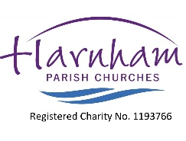For further information, please contact Charles Woodd at [charleswoodd46@gmail.com](mailto:charleswoodd46@gmail.com) or on 07962 213494.