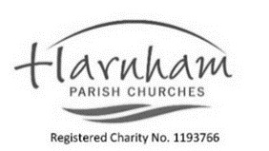
READINGS
Luke 20 v 27-38
2 Thessalonians 2 v1-5,13 - end
Sunday 9 November 2025.
REMEMBRANCE

PARISH DIARY November
Sat 8 | 10.00-11.45 | Coffee and Chat. Field View. HCN
Sun 9  Remembrance | 08.00  09.15  10.45  15.00 | Said Service. Short time of Remembrance at the peace. All Saints. Matt Stone LLM. Communion from reserved sacrament.  Sung Communion. Short time of Remembrance, at the peace. Revd Pat Clegg. Please note the time change due to Remembrance.  Remembrance. Memorial Hall. A service of the word with silence at 11.00 Revd Becky.  Messy Church. Trust. Ruth and Naomi. Parish Hall.
Tues 11 | 09.00 | Morning prayer. All Saints’ Churchyard.
Weds 12 | 09.00  10.00 – 11.45  15.00  19.30 | Morning Prayer. St George’s Church.  Coffee and Chat. Field View. HCN.  Funeral of Robert ( Bob) Pearce. All Saints’.  Folk Club – Harnham Sports and Social Club
Thurs 13 | 11.00  19.30  19.00 for 19.30 | Burial of Ashes. St George’s churchyard.  Pause for Prosecco. Field View  Deanery Synod. St Paul’s Foyer.
Fri 14 | 12.00  14.00  15.00-16.30 | Meditation and Taize. St George’s side chapel.  Funeral of Simon Overton. St George’s Church.  Parish Office open for key collection & Hall viewings.
Sat 15 | 10.00-11.45 | Coffee and Chat. Field View. HCN
Sun 16 Nov  Safeguarding  Sunday. All Saints’ | 10.00  18.00 | United Sung Communion All Saints’. Revd Michael Camp. Jacqui Brown preaching.  A special Evensong. All Saints’. Guest Choir Revd Becky and the Halcyon Singers. Choir director Andrew Hanley.

In our prayers …

Church: Poole Deanery, Rt Revd Matthew Mading Malok Madul, Bishop of Akot in South Sudan.
Harnham: those who serve in the military, those who have died serving their country.
The Crescent and Rowbarrow.
Growing in Faith and Action: The work of the Royal British Legion. Wisdom in the COP 30 conference. Those aiding the countries affected by Hurricane and Typhoon in the Caribbean, Vietnam and the Philippines.
Wholeness & healing: ceasefire in Palestine, Israel, Russia, Ukraine. Revd Simon, Margaret R, Mary C, William A, Tracey G, Jenny C, Julie S, Anne P, Sandra P.
RIP: Simon Overton. Bob Pearce.
Remembering

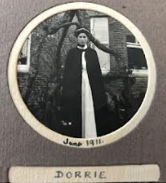
In previous years we have been silent about women from Harnham who have died in the First World War. Many nurses who died as a result of their nursing are not officially remembered. And so this year, we will remember Nurse Dorothy Julia Rossiter, Dorrie, who died on 16th December 1914 aged just 22 years old. She died from cerebral meningitis, contracted whilst nursing Canadian soldiers in hospital. She is buried in All Saints’ Churchyard, Harnham.
(With thanks to Liddy T and Helen Roberts.)

Events in and beyond the Parish Visit www.harnhamparish.org.uk

Christ the King Sunday 23rd
08.00 Said Communion. All Saints’. Matt Stone LLM communion from reserved sacrament.
10.00 United sung Communion. All Saints’. Revd David Callard. Revd Sophie.
Advent Sunday 30th
10.00 United sung Communion. St. George’s. Revd Michael Camp.

Thank you

Thank you to all who attended the Patronal Festival and Lunch last week. Thank you also to the team who helped prepare the lovely food, set up and clear away.
Thank you to Richard and James for organising the white lining of the car parks.
Advance notice

Wednesday 19th November Harnham Film Night. Social Club. The Salt Path, based on the memoir of Raynor Winn. She and her ailing husband Moth set out on a 630 mile walk along the South West Coastal Path.
Entry £5 on door. Bar open all evening. Contact Charles if lift needed.


Sunday 23rd November Community teas will take place. Entertainment will be from the Salisbury Pluckers. If you live alone and would enjoy time with others do come along. Could you invite someone whom you know would appreciate company and tea? No need to book.
Please contact Katharine Callard if you have specific dietary requirements or need transport.

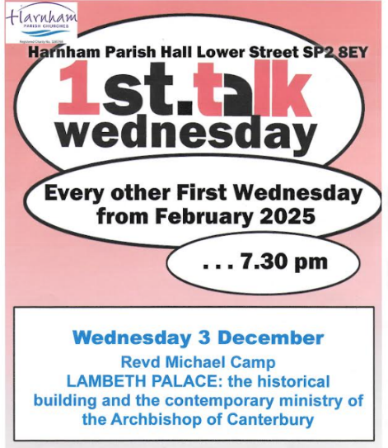
First Aid Training
– Wednesday 26 November (6.45 for 7pm- 8.30)
St John’s Ambulance have kindly offered to run a basic first aid session for us. It is intended to help us decide what action to take in common situations e.g. trips / falls. We would like as many parishioners to attend as possible, especially those whose roles include volunteering as Church Warden; Sunday Warden / Welcomer; Messy Church; Community Teas; First Wednesday Talks etc. because it would be good to have one or two people who have received some training present at all church events.
Venue – Parish Hall.
Please contact Jacqui Brown on 07909 648 309 or by email safeguarding.harnhamchurches@gmail.com

Encircles Salisbury, with whom we provide soup for on a weekly basis in winter, are looking for good quality sleeping bags for the homeless people they serve. If you have one please bring along to the Parish office on Friday 14th. NO duvets. Thank you. Revd Becky

Vicar: Revd Becky 01722 333564 reverendbecky@gmail.com (Day off - Saturday)
Curate: Revd Sophie details revdsophie@harnhamparish.org.uk (Day off Tuesday)
Safeguarding: Jacqui Brown 07909 648 309 safeguarding.harnhamchurches@gmail.com
Parish Administration: pccharnham@gmail.com New phone number 07476 349 965
Lift Coordinator: Pat Clegg 07450 217091 Email: Harnhamparishlifts24@gmail.com
When receiving any emails please check that they are from the above addresses. There has been another scam email address circulating this week supposedly from Revd Becky when it is not. Never ring back and never donate money in response to these emails. Always report them using phishing feature online.

