
Hire of Large Hall and/or Field View
Harnham PCC General Conditions
Parish Office, Parish Hall, Lower Street, Harnham, SP2 8EY
Email: admin@harnhamparish.org.uk, msg: 07476 349 965

General Conditions of Use and Hall Safety.
- All bookings are at the discretion of Harnham PCC and Harnham PCC has the right to refuse, and not give a reason, any booking application from any hirer(s) or group(s).
- Harnham PCC has the right to cancel a booking(s). This could be for a variety of reasons ie maintenance/repairs, elections, Parish events, community need etc.
- All bookings are subject to the following occupancy limits which have been approved by the Dorset & Wiltshire Fire Service:
Field View 40
Large Hall functions utilising tables and chairs 100
close seated audience 100
standing audience 150

When setting out close seated audience you must allow an aisle for access to emergency exits. Experience has shown that in these circumstances you only really have room for 80 to 100 in the Large Hall, especially with a “stage area” that is used by bands, discos, bouncy castles, projector table, buffet tables etc that take up some of the floor space and reduce the space for attendees.
- All property of the hirer(s) and all rubbish must be removed from the kitchen, toilets and rooms. If not, there will be a £20 charge deducted from the deposit.
- All advertisements and publicity for functions held in the Parish Hall must clearly display the name of the person or organisation holding the function. No bolts, screws, nails, tacks or adhesives are driven into or placed on any part of the premises. Posters or placards will not be permitted on the premises except upon the boards provided for that purpose.
- The hirer(s) are responsible for the proper conduct of everyone using the Parish Hall during the period of use. In particular, the hirer must keep noise to a reasonable level, having due regard for nearby residents, and should keep the main doors to the Parish Hall closed for this reason. The PCC or its authorised representatives may stop any meeting, entertainment or function, at any time, which is not properly conducted.
- Parties for children under the age of 14 must adhere to adult child ratios, and hirer must sign the Extra condition for hire for a children’s party.
- For safety reasons children must never be allowed in the kitchen, unless being closely supervised by a responsible adult during a specific cooking activity such as a Youth Club Cooking Class
- The hirer(s) are responsible for all damage done to the Parish Hall including any fixtures, fittings and any other articles in it during the period of use. Any such damage will be invoiced and settlement in full is required within 30 days to the extent not covered by any deposit.
- All electrical goods that you bring along to use in the Parish Hall must be PAT tested.
- All crockery used must be washed by hand or in the dishwasher and put away. Chairs and tables must be returned to their designated positions or returned to the storeroom. Chairs in the storeroom must not be stacked more than 8 high.
- If you use any of the tablecloths, please take them home to wash and return within 3 days.
- Any property or equipment left or stored in the Hall or in the hall car park, is done so at the hirer’s own risk and own insurance.
- Four large brown tables and 20 chairs are to remain in Field View at all times as this room is hired out on regular basis.
- Field View and the Large Hall are two separate rooms and are hired out individually. Unless you have hired both rooms, you must only occupy the room hired. It is not unusual for both rooms to be used at the same time by two different groups. When both rooms are in use, the kitchen is shared.
- The Large Hall must be swept and the kitchen and toilets left clean and tidy before leaving. If you use the cooker this must be left clean after use. All spillages must be cleared up immediately. The hirer(s) must ensure that all taps are turned off, lights and power switches turned off, and windows secured and doors locked when the premises are vacated. Any breakages or portable equipment considered un-safe should be recorded by email or by posting a note through the Parish Office Door. Further information on the shared kitchen can be found at the end of these conditions.
- In common with all public buildings, smoking is not permitted anywhere in the building. The use of electronic cigarettes and vapes are also not permitted on the premises.
- The hall is heated by an Air Source Heat Pump. The temperature is pre-set for each room. The thermostats in each room have been locked, as it is not possible to instantly cool or heat a room. Temperature variations take around 1.5 hours to take effect. Leaving the external doors open in winter will drop the room temperature rapidly so please keep external doors closed.
- The Parish Hall is part of eco church and we expect all hirers to use eco friendly cleaning products. Washing up liquid, hand wash and general cleaner are all provided on site.
- Keys are collected from the Parish Office between 15.00 and 14.30 on the Friday prior to your room hire and returned, through the letter box in the Parish office door straight after your booking. This time slot can also be used to visit the Hall and discuss your requirements for your event.

Hire Charges
- In addition to the hire fee there is also a £100 deposit to pay, which will be returned within one month of your booking providing you have adhered to these conditions (ie the hall has been cleaned, everything has been returned to its original place and you have taken your rubbish home with you). If not, the deposit, or part thereof, will not be returned.
- Should you cancel the booking 31 days or less before the date of hire. You will lose any deposit but we will return the hire charge that has been paid in advance.
- A booking is provisional until a scanned copy of the signed booking form and signed safeguarding agreement are returned by email, along with full payment to the Harnham PCC bank account at Lloyds Bank.
- All payments should be made by Bank Transfer to the Harnham PCC bank account at Lloyds Bank, Sort Code, 30-97-41 and account number 68625568. Please use your name and the date of hire (in DD/MM format) as your reference. We do not accept cheques or cash.
- Regular hirers pay as agreed with Harnham PCC. Harnham PCC is a charity, not a bank, and therefore hirers should expect to pay in a timely manner or risk losing their bookings.
- The person booking the Hall or Meeting Room must be 25 years or over and sign and return a completed signed booking form that acknowledges that they agree to abide by the conditions of hire as laid out in this document.

Child and Adult Protection
- Regular hirers who have any involvement with children are required to have their own Child Protection Policy and procedures.
- All ad hoc/casual bookings need to sign the Safeguarding Agreement and return with the booking form.
- It is the responsibility of the hirer(s) to ensure the protection of any children or vulnerable adults using the Hall.
- Parents organising parties for children must sign the additional Safeguarding form.
- If you are hiring the Large Hall, no access is permitted through the internal doors, or via the new kitchen, to Field View. (This is only permissible when hiring both the Large Hall and Field View ).
- If you are hiring Field View, no access is allowed through the internal door, or the kitchen to the Large Hall. Access to the toilets and old kitchen/storeroom is via the external Large Hall doors at the Eastern end of the Parish Hall.
- Hirers in the Large Hall must accept that visitors may access the toilets, not just from Field View but also from St. George Church.
- Harnham PCC has the right to cancel a booking if there is a risk of strangers coming into contact with Children or Vulnerable Adults.

The Parish Hall Field
We share the site with the Harnham Scouts. If you plan to use the Parish Hall field for your event there is an additional charge for this. We also need to check that the Scouts have no plans for the Scout Hall field at the same time. Please contact the Scouts if you wish to book the Scout Hall field and/or their car park.
Alcohol
If alcohol is to be consumed on the premises, a returnable £100 deposit is levied, payable with this booking form. The PCC does not hold a Liquor Licence. If one is required for your function YOU need to apply to the Local Magistrates Court or Local Council for a Temporary Events Notice, whichever is required for your event. Without the relevant licences alcohol cannot be sold, this also includes events where the ticket price includes a glass of wine. Please check with the relevant authorities. Please also let the Parish Administrator know that you intend to get a licence as the hall is only permitted to have 15 in one year, you will be refused a licence if the hall has reached its capacity. Any £100 deposit will be returned within a month of the hire if no damage is reported.
Insurance
The hall insurance details (public liability) are displayed on the notice board, just inside the main entrance to the Hall. However, the hirer must take out its own insurance to cover other claims which may arise in relation to its use of the Hall.
Private Parking
- The Private Car Park is for the use of patrons using the Parish Hall, and St. George’s Church for the duration of your hall booking or visit to the church. It is not a Public Car Park.
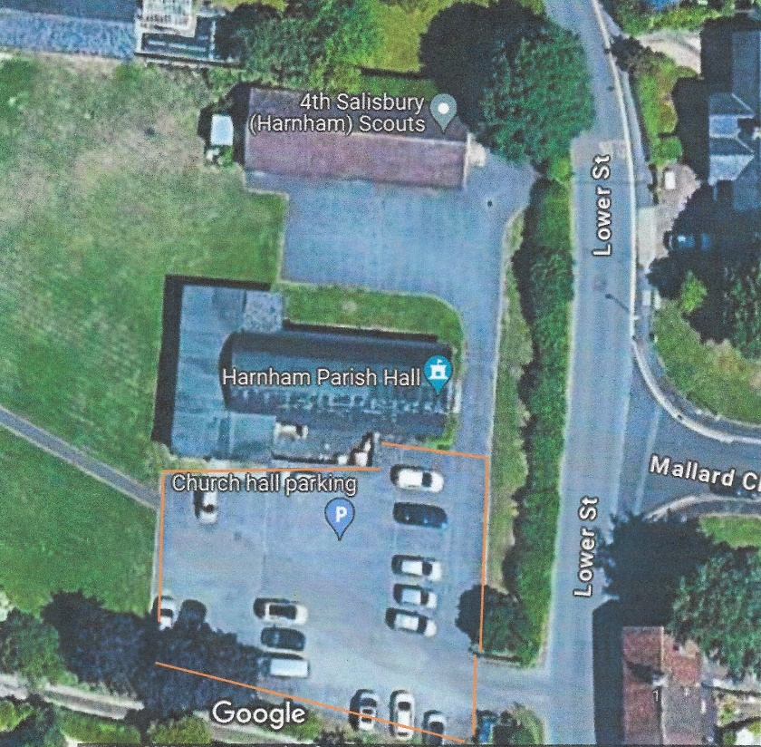
- Please only park in the highlighted spaces.
- The Scout Hall car park to the North of the Parish Hall is only for use by those using the Scout Hall.
- Hirers are advised that the parking spaces belonging to the Hall should be used sensibly. When leaving the Hall at night, consideration should be given to our neighbours and their right to a quiet and peaceful environment.
- All vehicles parked in the Hall car park are parked at the owner’s risk. Harnham PCC are under no liability to insure against loss, theft or damage to vehicles.
- All doors to the Hall must not be obstructed at any time and must be kept free for emergency services.
- Hirers should consider whether they need to control car parking. If a large event, parking should be controlled by marshals wearing high visibility vests.

Fire and Emergencies
- Copies of the Hall Risk Assessment and Fire Assessment are in the information folders in the Hall and Meeting Room. Hall hirers must be aware of their contents.
- The hirer is responsible for calling the Fire Brigade for any outbreak of fire, however slight, and for reporting this immediately to one of the Emergency telephone numbers below.
In the event of an emergency the postcode for the hall is SP2 8EY
- The hirer must ensure that all exits, emergency exits and fire appliances in the Parish Hall are free from obstruction and available for use at all times during the period of use.
- In the event of a fire, everyone should leave the building, ensuring, if possible, that all doors and windows are closed. Outside the building a check should be made to ensure that all persons are present. The Officer in charge of the Fire Brigade should be informed whether or not all persons have been safely evacuated. No one must be allowed to re-enter the building until permission is given by the Senior Fire Brigade officer present. Fire assembly point is on the South side of the grass next to the fence.
- All hall hirers must ensure that there is access to a mobile phone at all times when the Parish Hall is in use to enable contact with any of the emergency services should they be required.
- Any accidents that need to be recorded in the accident book need to be reported on the slips provided on the main hall notice board or in the Partish Hall Guides found in Field View, the shared Kitchen and the Large Hall. Completed slips to be posted through the Parish Office door.
Emergency Contacts
Parish Office | Parish Administrator | 07925 108856 | admin@harnhamparish.org.uk
Richard Scott | PCC Secretary | 01722 336126 | pccsec@harnhamparish.org.uk
Revd. Becky Roberts | Vicar | 01722 333564 | reverendbecky@harnhamparish.org.uk

Rights of Access by Harnham PCC
Harnham PCC and any persons authorised by them shall have the right to enter any part of the Parish Hall at all times.

FURTHER GUIDANCE – SHARED KITCHEN
We now have a new restaurant grade kitchen which is used by both Field View and Large Hall hirers. There are full instructions on using all the equipment on display or in a folder in the kitchen.
Please follow guidance on good food hygiene as well as Health and Safety.

As a general guide:
- Cupboards are all labelled, and everything is available for general use except for the plastic boxes labelled with individual group names of other regular hirers.
- Fridge and freezer : Feel free to use the but please do not use any of the items that are there on your arrival as this is for other groups that hire rooms in the Parish Hall. Please label clearly any items you leave in there if not for immediate use.
- Trolley worktops: Feel free to wheel the two moving trolley worktops out into the Large hall to use as a serving surface. (There are two moveable worktop trolleys, one has sides on and is a heated trolley, this is mainly for serving hot meals, the other has no sides but has a lower shelf).
- Sinks: There are three sinks in the new kitchen, one for hand washing, one for washing pots and one for washing fresh food.
- Commercial dishwasher: Instructions are displayed on the wall above. It needs 20 minutes for the water to heat up, so please turn it on when you start to serve so it will be ready when you clear crockery and glasses. Once heated you can load the dishwasher (only one tray at a time) and it has a 2 minute or 3.5 minute cycle. Once the wash cycle is finished, please lift tray on to draining board above and items should air dry in a few minutes. It is your responsibility to empty and put away all items in the dishwasher and empty the water from the bottom of the dishwasher after use.
- Tea towels: Should you plan to wash up by hand please bring your own tea towels. Any tea towels left in the kitchen after use will be thrown away.
- Hot Water Heater is provided .
- Filter coffee machine and flasks: please bring your own filters and ground coffee to use. Please us the 2 litre jugs to top up the machine with cold water.
- Cleaning work surfaces: Only use a soft cloth and the cleaning solution provided to clean the work surfaces. This is because some cloths and cleaners can scratch the surfaces.
- Outdoor coats should not be hung in the kitchen. Please hang coats on the coat hooks in the Eastern entrance lobby for the Large Hall or on the hooks by the entrance door to Field View. Personal bags may be stored on lowest shelf of the wire rack unit during kitchen use. Personal bags should not be stored on the worktops.
- It is your responsibility as the hirer to:
- Leave the kitchen and any equipment clean.
- Empty the dishwasher and put away all crockery and utensils. Please also drain the dishwasher of any water.
- The kitchen rubbish bins are for your convenience. All hirers are expected to take home their rubbish and remove the bags from the bins in the kitchen. (In common with other local Halls, The Parish Hall no longer has a regular weekly refuse collection).
- Report any breakages or empty supplies that need refilling. (This can be done by email or by putting a note through the Parish Office door).

