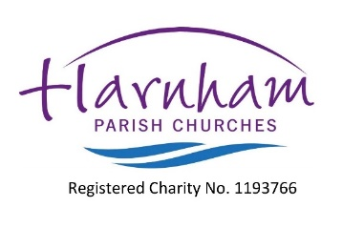
ANNUAL PAROCHIAL CHURCH MEETING
ANNUAL REPORTS - MAY 2022
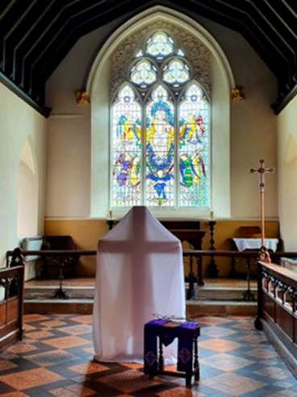
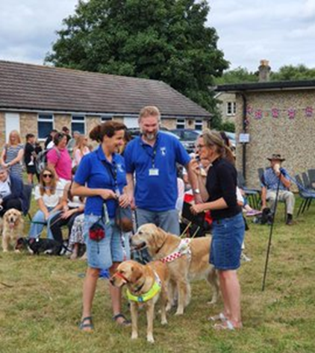
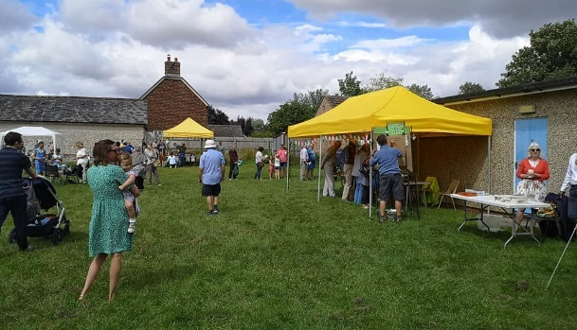
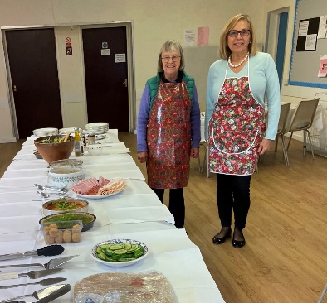
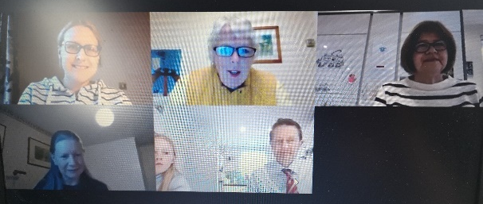
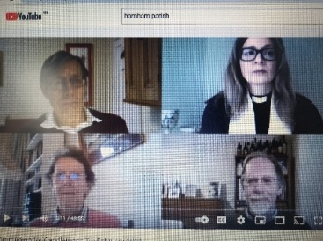

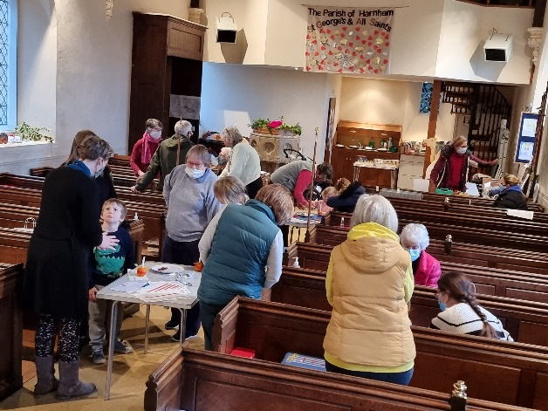
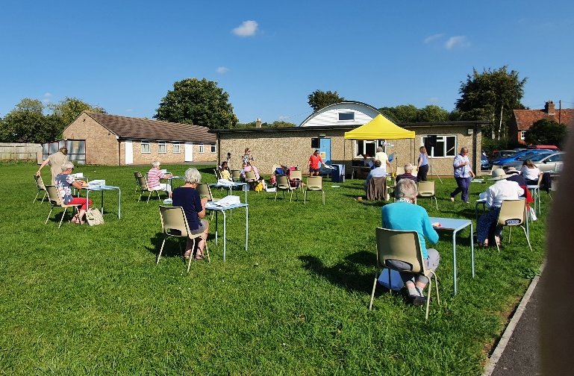

Contents | Page No.
Report on the proceedings | 2
Vicar’s Report
Assistant Priests Report
Curates Report
Licensed Lay ministers Reports
Churchwarden’s Report
Mission and Vision
Worship Report
Parish Hall Transformation Project
Property
School Governance
St George’s Toddler Group
Messy Church
Pop Up Youth
Mothers Union
Pause for Prosecco
Eco Church
Social Report
Communications
Safeguarding Report
Finance Working Group

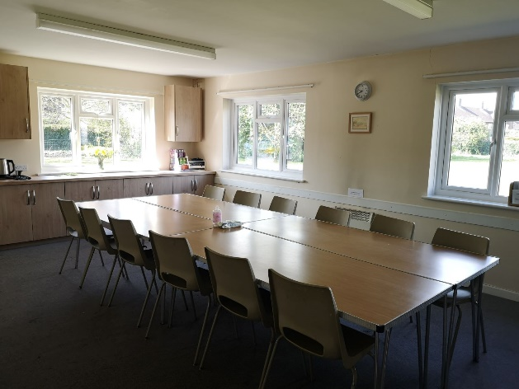

The upgraded Meeting Room in the Parish Hall

REPORT ON THE PROCEEDINGS OF THE PCC - FOR APCM 2022
The APCM in 2021 was held on 28th April 2021. The majority attended this meeting via Zoom and a few in person, socially distanced and wearing masks.

Since the APCM there have only been 5 PCC meetings. The average attendance has been 75%.

The parish is entitled to have 9 elected members of the laity on the PCC, due to the fact there 156 members on the Electoral Roll.

The Standing Committee members are the Vicar, Assistant Priest, PCC Secretary, Churchwardens, Parish Treasurer and a lay member. (For the past year Lay Chairman has been one of the Churchwardens).

During the year, the following people served on the PCC:

EX OFFICIO
Revd.Becky Roberts Vicar
Revd. Julian Poppleton Assistant Priest
Revd Mike Badger Curate (from August 2021)
Charles Woodd Churchwarden – St George’s
Jane Greenaway Churchwarden – All Saints (up to APCM 2021)
Robert Salkeld Churchwarden – All Saints (from APCM 2021)

CO-OPTED MEMBERS Michael Fisher - Treasurer
IN ATTENDANCE Linda Baker - PCC Secretary

Deanery Synod Representatives following the APCM 2021:
Neil Turpin, Katy Carter and a Vacant position.

ELECTED MEMBERS following the APCM 2021
- Sue Reeder (From 2017)
- Olivia Thomson (From 2018)
- Julia Woodford (From 2019)
- Emma (From 2020)
- Val Overton (From 2020)
- Jill Tilley (from 2021)
- Ann McGarry (from 2021)
- Debbie Mussellwhite (from 2021)
- Vacant

Nich Brown, Kate Mash and Tony Mercer served up to the APCM in 2021

In addition to the full Parochial Church Council, there are sub - committees to cover a range of parish work. These committees are:
- Standing (core members of PCC, i.e. Vicar and Churchwardens, who set the PCC agenda and make recommendations to the PCC)
- Social
- Worship
- Communications
- Youth and Children ( i.e. Messy Church, Toddlers, Foundation Governor)
- Mission and Vision
- Property
- Hall Management
- Parish Hall Transformation Project
- Eco Church
- A Finance Working Group has met during the year to organise stewardship and review and develop the Parish’s approach to fundraising

Over the last year the PCC’s work, often under the sub - committees, has continued where possible during the pandemic and has included:-

- the continued upkeep of the two churches and Parish Hall.
- keeping up to date with all Government and Diocesan guidelines on opening and closing of buildings and maintaining Covid safe buildings.
- continued work on the transformation of the Parish Hall, working with hall users to open again safely following lockdowns and continued fundraising.
- continued work in the churchyards to make them Eco friendly.
- regularly reviewing worship and adapting to the changing times.
- surveying the needs of the community during the pandemic.
- reviewing the finances of the parish
- maintaining ways in which the Parish communicates with both electoral roll members and the wider community, especially during the pandemic but also for the way forward.

VICAR’S REPORT
Now these three remain faith, hope and love, the greatest of these is love. 1 Corinthians 13 v 13
A summary
Pray and Serve
At this point in 2022, we can look back to 2021 and be thankful - for the reopening of the churches, for the vaccination programme, for the re-emergence of community life, for the relative peace and prosperity we have the freedom to enjoy, for our faith in community and the love that has seen us through the last year.
There is much to celebrate that renews our hope - new joys in worshipping together both outdoors and in united services, new members and licensed ministries, new connections made within our community through the Harnham Community Network, a new hall kitchen and meeting room which provide so much space and light, renewal of pastoral care such as Mother’s Union Community Teas. A bereavement course has been explored and will be led for the community. Messy Church numbers are now growing again, along with requests for baptisms, blessings, and a few weddings.
The year has also been one of challenge and loss - some members have not returned to worship; some of the faithful members of our congregations have passed away, Jane Elliott, Revd Charles Rolfe, Bruce Eagles, Marion Webb, Pat Sansome, Revd Brian Coleman to name a few; some members of the congregation have moved away to be near family such as Sister Theresa Kennedy, others have experienced illness and now receive home communion.
Income has fallen as daily running costs and the allocation of the Parish Share increase. We have run a stewardship campaign and I would like to thank all who have considered their contributions.
Overall congregation members on a Sunday morning are between 1/3 and ½ fewer than pre-pandemic.
As the Most Revd Steven Cottrell reflected - These crises are not signs of the absence of God but calls to recognise the presence of the kingdom and to act in faith and courage, simplifying our life focusing on Jesus Christ, looking outwards to the needy and renewing in ourselves our call to wash feet, to serve our society and to be the Church for England.
It is worth remembering that it is through challenge and loss that we can choose to grow.
Grow
As a community we have explored the themes found in the Prodigal Son - of being welcoming, of looking outward, of inclusion.
We continue to develop access to study and worship with Information Technology. We have re-introduced 8am services to which a few people have now returned who had not attended any other form of worship. We have re-introduced more informal services of the Word at All Saints and the congregation regularly engages with discussion as part of learning together.
It has been a joy to see the licenced ministries of Matthew LLM, Katy LLM and Revd Mike develop over the year. We are fortunate to have so many gifted people both licensed and as part of our congregations serving the church and community.
We must continue to develop real relationships with our community, especially the missing generations.
The Archbishops reiterated the need to have three points of focus for the 2020s - a church of missionary disciples, a church which is mixed in its ecology (fresh expressions and traditional), a church that is younger and more diverse.As a PCC we agreed to the following points for the year 2021/22:
- Support efforts for financial viability in the longer term with a better approach to fundraising
- Move the Parish Hall Transformation Project on significantly towards creating Harnham Hub
- Collaborate with the Harnham Community Network and widen its use
- Promote an understanding of the need for all age and inclusive worship and plan this, encouraging laity to be involved. Offer worship including communion and informal worship
- Promote ourselves as an inclusive church – being bolder about our inclusivity
- Offer courses for a wide range of people at every stage of faith and life
- Make the best use of the buildings and grounds, promote our presence
- Make best use of online technology
- Promote a safe church and hall and build up the confidence of those who need to return to church buildings
- Use the outdoors, which brings people together
- Act in response to the climate emergency - The Diocese is aiming to be carbon neutral by 2030 - include younger people in exploring how to do so
- Provide pastoral care to the whole of Harnham
- Encourage the ministry of Mike Badger, part time pioneer curate, and engage with an understanding of pioneering
- Embrace the new housing in Harnham. Make ourselves known as welcoming: invite

On a personal level, I have served the community much more through listening to those who are isolated and families ‘on the edge’, those who are supporting loved ones with Alzheimers or have experienced sudden deaths of loved ones. I have enjoyed my first Sabbatical placements at Holy Rood centre of healing, exploring the use of creative therapies, in particular art therapy, to process trauma and learn more about trauma theology in order to inform trauma friendly practices in our churches and community. Specific points of growth have been in representing the views of the Parish after being elected to Diocesan Synod; leading and supporting the Harnham wide team; vision discussions and study through a 4 day Pioneering Parish course led online.
Thank you to all who have shown flexibility this year in taking on new roles and adapted to new worshipping formats. My thanks to Robert and Charles as churchwardens, all the licensed team, the standing committee and PCC and Linda as administrator. To all of you who give your time voluntarily, who pray and serve, THANK YOU for being part of God’s kingdom in Harnham, acting with faith and courage and of course love.
Revd Becky Roberts
---------------------------------------------------------------------------------------------------------------------------------------------------------
ASSISTANT PRIEST’S REPORT
Pray
It’s been a busy year and a demanding one for our family and for the parish. I greatly valued the prayers of those who have supported me and the family and in walking alongside our church through tough times. Much to rejoice in, with open air and inside services, leading and celebrating the Eucharist, key moments in our common life and that of individuals; singing, helping with recorded music, learning and sharing with each other under God’s love.
Joy to return to being able to get back inside our churches and to join with the saints and lineage of faithful worship in those spaces. As I tend to this time, it was very good to see the 8am congregational return and to welcome visitors and new friends and also to be involved in powerful and spirit-filled gatherings for Harvest and Remembrance.
Equally a privilege meeting and preparing couples for marriage, baptisms, funerals and the committal of ashes; there have been rich opportunities to hear peoples’s stories, their understanding of faith and experiences. Always a profound experience.
Serve I was pleased to support the team so that Revd Becky could take the first part of her sabbatical; I continued to work on the specifications, negotiations and ordering of the new audio visual installation for All Saints and a portable livestreaming kit for St George's. A number of services were recorded and livestreamed with our home grown kit which has meant a lot especially to those unable to attend major services.
It was a demanding experience to sit as a juror for several weeks on a very tragic and distressing case. I was grateful for the ministry of the chaplain to the Law Courts.
I was saddened that Libby and I weren’t able to gather the choir for the full version of the carol service we have offered pre-Covid. It was good to meet for worship nonetheless. We know the youngsters felt bereft and can’t wait for next year.
Grow
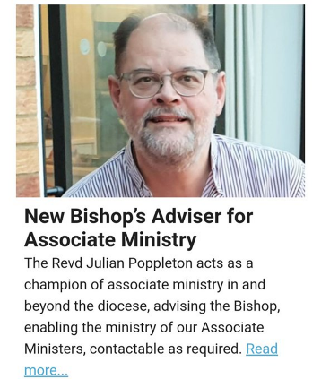
It has been enriching to work alongside so many talented folk, with new colleagues bringing a wealth of experience to prayerful initiatives and exploration of our shared mission. The St George’s musical evenings were a particular, illuminating joy as were our Lent and Advent talk series. The welcoming of a child and his family in baptism and the establishing of connections through funeral and burial has been gratifying and encouraging.
The portfolio of my activities in the church beyond the parish have also grown. As Bishop’s Advisor for Associate Ministry I attend regular national meetings and speak to our own Bishops and diocesan staff on national and diocesan matters. I also serve on the Clergy (and families) Wellbeing group. I am also a member of Deanery and Diocesan Synod that continue to manage considerable challenges for our church life and witness. I have also been busy leading worship as stand-in precentor at both Winchester and Salisbury.
I am deeply grateful for the support from my colleagues and the parish.
Revd Julian Poppleton
-----------------------------------------------------------------------------------------------------------------------------------------------------------
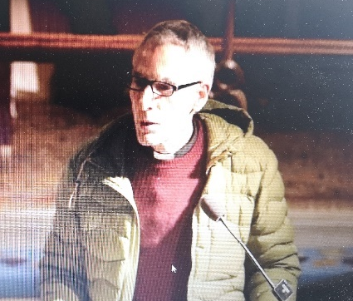
CURATE’S REPORT
Pray, Serve and Grow
Would you believe that I have been with Harnham Parish for almost one year now and I thank you for your welcome, support and patience with me. In this time, I have learned much about Anglican tradition from a different perspective to that of which I have been a part until recently. In particular I have experienced the wearing of robes, the rhythm of traditional morning prayer at St George’s and the choreography of Sunday communion services aligned to the seasonal colours.
Whilst I am a pioneering curate, most of my church ministry work this year has been participation in the leadership of established forms of Anglicanism. This has been deliberate and was advised by the Diocese. This is part of getting to know the place of which I am now a part. That said, it has been good to participate in diverse forms of ministry such as the Pet Blessing Service, Beer and Carols at the Old Mill, and the chance to lead carol services with the Scouts and Harnham Croft. I also shared a lovely time with the Mother’s Union exploring how we might understand a contemporary application of The Ten Commandments.
However, it has been a challenging year for me too as we have grappled with the realities of a seriously ill son whilst endeavouring to take over the running of the Salisbury-based Charity called Morning Star, as well as trying to get settled into a new church family and meeting the requirements of the diocesan curacy programme. So, there has been much juggling of hats between husband and father, grandad, charity worker and Anglican Church ministry. But each time I have doubted my calling in all of these aspects of life, the Lord reassuring reveals himself to me and is my comforter and guide.
Revd Mike Badger
-----------------------------------------------------------------------------------------------------------------------------------------------------------

LICENSED LAY MINISTER’S REPORT
Pray, Serve and Grow
My first full year as an LLM in Harnham could be described as an interesting one, Covid restrictions inevitably bringing some disappointments as well as new challenges.
Throughout the year I continued to lead intercessions regularly on zoom, at outdoor worship and then indoors at both churches. It was a particular joy to finally have the opportunity to preach in person to a ‘real’ congregation, something I had particularly missed.
In addition to occasionally leading worship on Sundays, I have regularly led Tuesday morning prayer at All Saints, which is attended by a small but regular (and hardy) group of individuals. It has been encouraging to see others take on the role of leading that particular service.
It was a real privilege to be given the opportunity to preach at this year’s Services for the Bereaved and to lead our Service of Healing and Wholeness held at St. Luke’s tide.
Continued Covid restrictions have prevented my becoming involved in the Junior School as hoped, but I did have the opportunity to take part in the school’s Harvest Assemblies along with Revd. Michael Camp, which made me realise how much I missed being around children.
I continued to attend meetings of Deanery Synod as one of the Parish’s representatives and was finally able to enjoy meeting some of the other Synod members when we held a ‘live’ meeting in November.
This summer I again volunteered at the Harnham Harvest Table and from the end of May became a regular volunteer at the newly-launched Saturday morning ‘Coffee and Chat’, organised by the Harnham Community Network, which has continued each week with just a short break while the Hall was out of use. Also at the end of May I was elected as a member of the newly-formed committee of the Harnham Community Network.
Katy Carter
----------------------------------------------------------------------------------------------------------------------------------------------------------
LICENSED LAY MINISTER’S REPORT
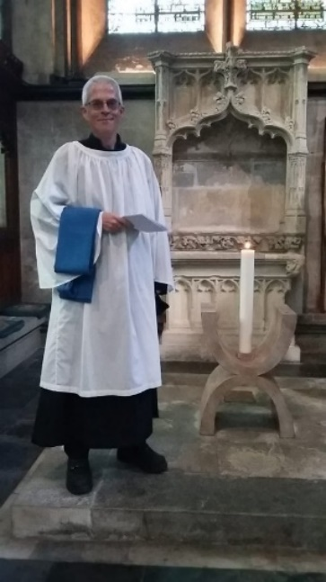
Pray, Serve and Grow
Since my licensing in September it has been a pleasure to preach and on several occasions, to lead services within the parish.
It has been with a sense of hope that I’ve watched our churches move toward normality after the Covid lockdowns. It was important to see the church doors open again as these places offer not only a sacred space but also a sanctuary of stability where we can reflect on our turbulent world. Such reflection was abundant during our Advent Talks which I had the privilege to help organise late last year. During these we were blessed to welcome a number of speakers who meditated on the search for peace during our lives and especially in times of crisis.
Once my training ended my voluntary work outside the parish also returned and I was again able to assist the chaplains at our local hospital. This included a visit to the wards on Christmas Eve and helping to lead an Advent service broadcast on Radio Odstock, which was great fun!
Matthew preparing for his licensing.
This work and that in the parish are still greatly affected by what we have been through these last two years, but even in the few short months I have been a licensed minister, I have witnessed a strong commitment to rebuild.
Matthew Stone
-------------------------------------------------------------------------------------------------------------------------------------------------------
CHURCHWARDENS’ REPORT - St George’s and All Saints Churches
Pray
At All Saints during 2021 there were thirteen funerals (two with interments), two burials of ashes, two baptisms, one blessing & no weddings. The Epiphany service on the 3rd January was the last before a re-imposition of a Covid lockdown. Between then and May one funeral, one Easter service of prayers on Holy Saturday and a service of Celtic Prayer in mid-May were the only services held inside the church.
Fortnightly Sunday services inside the building did not resume until the very end of May, when attendance at the monthly 8am Communions was as high as 21, and at the 5th Sunday 10.30 Communions attendance approached the church’s (Covid) capacity, then at 40. Tuesday Morning Prayer at 9am in the churchyard also started in May and only moved indoors with arrival of winter weather, with a regular attendance of between 4 & 7 persons.
It was October before the provision of at least one service every Sunday on a revised service pattern was resumed with an increase in (Socially - Distanced) capacity of 55. There were 24 at the first 11am (Harvest) Communion on the 3rd October and 38 at the 10.30 Joint Communion Patronal Service on 31st. From then on attendance at the ‘1st Sunday’ 11am Communion services has been between 15 & 20, with similar attendances at the new 11am Services of the Word, while that at the 8am Communion services has been 8 -10. At least 15 persons attended an evening Service of Healing during this period and during Advent, the Compline Talks were well-attended by as many as 21 persons.
The tightening of Covid restrictions owing to the spread of a new variant was the probable reason why - apart from the two Nativity services that were attended by a total of 39 adults with 17 children - the numbers of those at what are usually the better-attended festivals of Remembrance & Christmas were similar to those of 2020 rather than 2019. For instance, the 11am Communion Christmas Day service was attended by 17 adults and no children.
At St George’s, there were 3 funerals or thanksgiving services, 7 burials of ashes, and I wedding during the year. Particularly notable was the thanksgiving service for Jane Pelly, a Lay Reader who gave so much to the Parish over many years. It was attended by over 100 people, including some watching a live broadcast in a marquee in the Parish Hall field. The congregation included a lively contingent of Jane’s former pupils from Nigeria, who brought with them copies of a book of tributes to Jane published by the school’s Old Girls Association.
Attendance at regular outside services during the summer, held in the Parish Hall field, averaged between 30 and 55, while attendance at services in St George’s, once we were able to return to indoor worship, varied between 25 and 35, with 2 to 5 people at Morning Prayer on Wednesdays.
Services at Christmas in St George’s included a short nativity service for the Toddlers Group, and an outdoor Christingle service for the Scouts round a brazier in the field.
Serve
During the spring we welcomed Revd Mike Badger as Pioneer Curate, and during the autumn Revd Becky took a sabbatical from her work in the parish. Linda Baker, Revd Julian, Katy Carter with the retired clergy and Revd Mike all supported Revd Becky’s work and continued it in her absence. This year Matthew Stone started work as a new LLM. Canon David Durston is due to leave the retired clergy team following his recent serious illness, as he and Tricia plan to leave Salisbury, and we wish them the best for the future.
In June Jane Greenaway stepped down as Churchwarden after 7 years and was replaced by Robert Salkeld. Jane has worked very hard for All Saints, especially during 2020, and she has also contributed a great deal of effort towards the Parish Hall Transformation Project. We thank Jane for all her work for All Saints and for the parish.
Throughout the year the church has been fortunate in the small band of those who came into both churches, initially to keep the dust under control and since then to keep it clean and disinfected once regular services re-started. They were supported both by others who turned out to give it a really good clean before this happened and by those who have kept the church’s linen clean. Since October it has been worthwhile to re-introduce formal rotas to cover cleaning and linens. The Flower arrangers have also started work and once again both churches have been adorned for all manner of services since then. The Parish is very fortunate in having people who give of their time so generously and if anyone else would like to join in and help with the cleaning, the linen or the flowers, then they should speak to the Churchwardens.
We continue to be grateful for the dedicated efforts of Kevin Clarke, and all those who help to maintain the churchyards.
Buildings
As part of our Eco church policy, all our three buildings are now supplied with electricity from 100% renewable sources. An attempt to fit a smart electricity meter in All Saints failed owing to problems with the wireless signal locally. Meter readings continue to be submitted monthly.
Churchyards
The Parish has received Bishop’s Awards for two years’ continued Ecological Management of both Graveyards. Piers Mobsby, who voluntarily created and tends the wildflower patches for the Parish, led a Sunday wildflower tour of the All Saints churchyard during the summer. Meanwhile, works to improve & maintain the buildings during 2021 include:
The annual shared cut of the All Saints churchyard hedge that was carried out during January.
The flower bed outside the porch at All Saints has been established and gave us its first display of spring colour.
During the autumn, the eastern walls of All Saints churchyard bounding No 64, Harnham Road, have been stripped of ivy; some ivy has also been removed from the southern wall.
The Faculty for the new noticeboard at All Saints was approved and despite it then being subject to some last-minute changes (caused by unknown buried plant) agreed by the Archdeacon, the noticeboard has been installed.
During December two graves in All Saints were fitted with kerbs not permitted by the current graveyard regulations. The relevant next of kin have been contacted and one grave has since been restored. However, the other may soon be in hands of the Diocesan Chancellor.
The two lamp post lights in St George’s churchyard were repaired and LED bulbs fitted for greater cost effectiveness. The Quinquennial Inspection of St George’s recommended urgent repairs to the stonework of the West window, which are to be undertaken during the Spring.
Grow
The memory stars in the two churchyards proved popular once again this year.
Following the lock-down in January, a number of services, including monthly Messy Church services, were recorded and placed on the Parish YouTube channel to enable people to participate in the worship from home. Later in the year, some live services continued to be recorded and uploaded to the Parish YouTube channel, so enabling people to ‘attend’ who were prevented from doing so by Covid restrictions or other reasons. These included funerals, Messy Church services, Advent Talks and services for various festivals. Although Covid prevented our loyal choir of young people joining us in Harnham for our traditional Carol Service in All Saints, Revd Julian was able to organise a live Carol Service which also included carols recorded in previous years, and this was also then made available on YouTube.
Buildings
A Faculty application is in hand for the installation of a new Audio Visual system in All Saints. Some minor works that would have to be done in advance of installation have been identified and are being put in hand.
Over the year the exterior of the chancel wall in All Saints continues to dry slowly following the removal of the cypress, but any effect on the damp inside is not yet obvious.
A QR-code to be visible outside All Saints and linked to an online version of the Church Guide has been suggested.
The boiler room in St George’s has been fitted out, through the good offices of Gary Price, to serve also as an overflow storage area from the Parish Hall.
Churchyards
There has been no progress this year with a survey of either churchyard, although the announcement during the year of a national initiative to survey every graveyard in England within seven years was a welcome one.
The heap of waste in the angle between the wall with the fence to the rear of No 64, Harnham Road remains.
Following a consultation with a stonemason to confirm that the use of existing flagstones as the base for a bicycle rack was feasible, the work to install the new All Saints noticeboard nearby revealed unknown (drainage?) pipes which will need to be traced and identified before a design can be completed.
Robert Salkeld and Charles Woodd, Churchwardens
--------------------------------------------------------------------------------------------------------------------------------------------------------
Committee Members:
Revd Becky, Jane Greenaway, Linda Baker, Joanna Woodd, Jean Mercer, Katy Carter.

MISSON AND VISION
Pray, Serve and Grow
Mission and Vision Committee met once last year, whilst other mission opportunities were considered by the whole congregation and staff team and churchwardens after the Vision Sundays.
The overall vision of Harnham Parish Churches has been to be a vibrant, inclusive, worshipping community that prays, serves, and grows. Pop Up Youth group has been set up with an average attendance of 12 tweenagers (9-13 year olds) and will need to be relaunched after Covid 19.
Messy Church has continued well online, and in real time, with deliveries and pastoral care - some new team members and families. It builds on links with local families and school communities. Baptism Preparation also takes place in Messy Church - two families attend regularly from those who were baptised.
The Parish Hall Transformation Project is now working towards creating Harnham Hub; the redevelopment is taking place in phases with £30,000 raised in the last year alone. The Harnham Community Network has provided vibrant links in our community to those who are vulnerable and those who just would like to meet up and share. There is a hub of people gathering from different parts of the community.
Events in the community have included The Great Day Out, Harnham Drive around Nativity, links with the local Schools and serving on the governing body, Christian Aid collections, Fun treasure hunt for families, Eco Churchyards and Pet Festival and Country Fayre, Saturday Coffee and Chat run by the Community Network in the Hall meeting room. New technology has been introduced and used for outdoor services and indoor live streaming, especially during lockdown and the Harnham Parish YouTube site has been developed.
In a brain-storming session, the group identified a range of issues facing local residents: - families struggling to survive on low pay or benefits; - isolation among both young parents and elderly and disabled people; - the limitations imposed on many residents by physical and mental disabilities; - the difficulty of sharing information across the neighbourhood without a regular free community newspaper for Harnham; - the need for accessible ante/ post-natal classes within the neighbourhood; the lack of informal facilities for young people locally, particularly since there are no secondary schools in Harnham; the need for more local holiday activities for young families, especially where both parents are working.
Pastoral Support for all continues with Church Links, 4 Lay Pastoral Assistants, as well as licenced ministers, formal and informal groups such as the Mother’s Union. 14 people made telephone conversations with all on electoral roll in lockdown
A Bible Course was run twice with over 22 people attending, regular Bible study on the Old Testament has continued online once a month, Lent and Advent courses have been run with varied foci on social justice, the Bible, art, and poetry that help us understand the true meanings of Christmas and Easter, Pause for Prosecco – a group that explores the big questions in life - has run throughout lockdown
PCC has agreed to remove pews from AS and some from SG. St George’s sound system has been replaced. A permanent projector & screen, replacement sound system & live streaming capacity is planned for All Saints.
The context of Harnham itself is changing with new houses being built, population growth, a change of community. The context of the church community is also changing, eg a significant number of older members have died over the past few years, others are ageing and losing mobility or confidence, there has been a growth in the pastoral connections in the church community and wider community through the Harnham Community Network and Messy Church. Our church community does not reflect the demographic of the wider community, for instance in a recent survey about worship only one person under 40 years old responded. The wider context of the Church of England is also changing in the Diocese and Nation. Pastoral reorganisation plans are happening in Sarum Archdeaconry. Clergy numbers are being reduced. Most ordinands entering the Diocese are self-supporting ministers. The Church of England Vision for the 2020s is for a church that is centred on Jesus Christ and shaped by Jesus Christ – a church that is simpler, humbler, bolder; the strategic priority to be a church of missionary disciples; to be a church that is younger and more diverse. Christians are both invitational and missional - welcoming in and going out.
For a long while now the church vision has been to be a vibrant inclusive worshipping community that prays, serves, and grows. There have been many types of worship offered on Sundays at 8am, 9.30am, 11am, as well as Messy Church and Pop-Up Youth. During covid there have been online reflections, online worship, outdoor worship, time for private prayer and indoor 8am worship at both churches. We continue with online Thursday prayers at noon. We offer traditional BCP, Eucharist, Service of the word, with a focus on understanding more of the Bible, and All Age communion. To grow a diverse and younger congregation we may need to let go of some things - to simplify.
The PCC also considered its vision for the parish in its aims for the year which are set out in the Vicar’s report that gives an overview.
Revd Becky Roberts and Linda Baker
--------------------------------------------------------------------------------------------------------------------------------------------
Committee Members:
Revd Becky, Revd Julian, Katy Carter LLM, Charles Woodd, Val Overton, Ian Davidson, Katy Carter, Jacqui Brown
WORSHIP
Pray
Much of the data for worship is contained in the Churchwardens’ report. Whilst the churches were closed and communion was restricted, we opened churches for prayer, held zoom coffee and weekly noon prayers, zoom services of the word and communion on Sundays. Outdoor morning prayer was held twice a week. We moved to holding services outside every Sunday at 10.30 which were greatly appreciated and varied from an outdoor baptism, Messy Church picnics, to all age communion with more modern songs and a shortened liturgy. Attendance at outdoor worship averaged in the mid forties with some people attending from other churches and even visiting for the outdoor service. Different sermon themes were explored: The Old Testament series, the Prodigal Son and Eco Church. From October, services were held inside both churches with new timings being trialled in order to give space for clergy to move from one church to the other. Timings were readjusted to 8am, 9.30 and 11am after some feedback. Sermon series and online discussion groups in January included: What is our worship based on? What is prayer? What is intercession? Prayer and personality.

Serve
We are a small church community - many of us serve in different ways as part of our daily worship - such as court chaplaincy, day centre or school governance, Harnham Community Network, phone calls to those alone. Worship services held in our community have restarted as follows:
- Brympton House accommodation monthly communion and discussion with a regular attendance of 8 persons. Revd Mike has taken on leading communion regularly at Harnham Croft. Revd Becky and LPAs continue to visit and take home communion to those who are unable to attend church for various reasons.
- Harnham Junior School Worship continues to be recorded and linked to the values for each term. It was encouraging to get feedback on these from children. In the Autumn, Father Michael Camp, as foundation governor, led a Harvest service with the school children in person for the first time since lockdown. Unfortunately, but understandably, these in-person acts of worship did not last but continue on video with much thought and preparation.
- We have served those in pastoral need well through the offering of the annual bereavement service, live streaming for pastoral services and extra pastoral care in preparing for burials and funerals.
- Toddler services have been held once a term supported by Revd Penny Joyce and Revd Becky.
The Vicar, Standing Committee, Worship Committee and PCC have been continually reviewing the C of E guidelines for worship, often making difficult decisions as to how to implement them. In January 2022 guidelines changed again allowing communion in two kinds, however after much consideration of the local situation the PCC decided to maintain the status quo and review the situation again in March.
Grow
We cannot deny the fact that congregational numbers are down, however our motivation to grow is rooted in the desire for people to know God’s love. We need to continue to create attractive communities of belonging and believing and to listen to our wider community’s needs. Ways forward and things to celebrate include:
- The return of singing! We aim to develop more live music and thank Ian for his contributions in playing the keyboard outdoors and church organs indoors. A scratch choir is planned.
- Pioneering Café Church as one way forward in order to attract families alongside Messy Church.
- Building communities of belonging through learning groups, relevant talks and social events.
- Promoting blessings / renewal of vows as these are increasing through pastoral relationships built up.
- Being active as congregations in inviting people to events and church.
- Opening up our churches more e.g. Prayer stations over Easter.
Revd Becky Roberts
--------------------------------------------------------------------------------------------------------------------------------------------

PARISH HALL TRANSFORMATION PROJECT
Project Team:
Charles Woodd, Jane Greenaway,
Linda Baker, Chris King, John Newsome,
Paula Price

Pray, Serve and Grow
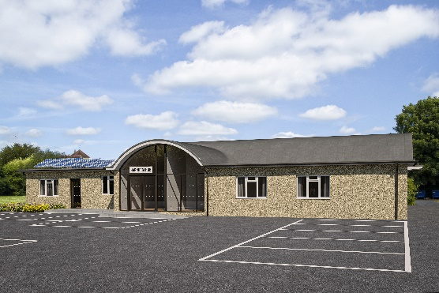
During the early part of the year, thanks to the Covid restrictions in place, little progress was possible on the fundraising necessary to carry the Transformation Project forward. However, the Great Day Out held in the Parish Hall and field on 31 July enabled local residents to gather and celebrate the lifting of restrictions (at that time!) and to see for themselves the plans for the Project, and the Parish to launch the Harnham Hub Appeal, in collaboration with the Harnham Community Network. The Appeal received a wonderful boost from a very generous donation of £10,000 from Harnham Inc, a global company founded by a local lad from Harnham, Simon Clarke, and a £5,000 grant for Wiltshire Council’s Salisbury Community Area Board, to support the installation of a new heating system. Many other local residents and businesses sponsored the Appeal, enabling us to reach a total of £47,000 by the end of the year. The Parish is very grateful to the Patrons of the Appeal - Simon Clarke (see above), Robert Key (former MP for Salisbury), and Andy Maslen (author and local resident) for their support.
With funds previously raised, and grants awarded but not yet received, and access to some restricted funds, the PCC was able to authorise the implementation of the first phase of building work, making much needed improvements to the existing building. These include the replacement of the old, expensive and ineffective heating system with underfloor heating powered by two air source heat pumps, the creation of a new catering grade kitchen in the space that was the store room, located so as to be able to serve the Hall and Meeting Room directly, and the supply of 3-phase electricity to support these new facilities. This work was scheduled to be completed in early 2022, under the painstaking eye and tireless project management of John Newsome, supported by an active volunteer team including Sandra Newsome, Jane and James Greenaway, Paula and Gary Price, Tony Mercer and assisted by our Parish Administrator, Linda Baker.
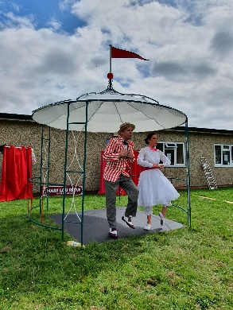
Harnham Community Network was initiated in 2019 to link with and support the aspiration that the transformed Parish Hall become a centre of activity and outreach for the whole of Harnham, subsequently designated Harnham Hub. The Network, constituted formally in May 2021 as a small charity, had an active year. The Harnham Harvest Table, facilitating the sharing of surplus fruit and veg from local gardens and allotments amongst neighbours, returned for a second summer of Saturday morning stalls, mostly in the Parish Hall field, but also moving twice to Rowbarrow in East Harnham. The Network also initiated a Coffee and Chat session in May on a Saturday morning at the Hall, which by the end of the year had become a very regular feature with a loyal following of 15 to 20 attendees, and a dedicated team of volunteers coordinated by Isabel Waters. The Network created its own website www.harnhamcommunity.org, and agreed to assume responsibility for the welcoming of new residents, taking over from the PCC the editing and production of the Welcome to Harnham Pack.
In the coming year, the Project Team will be reviewing and refining the plans for the extension to the Hall and further renovations and improvements, drawing on the experience of Phase 1, and taking account of substantial increases in building costs. This will provide the basis for our bid to the National Lottery Community Fund, and a renewed round of fundraising.
Charles Woodd
---------------------------------------------------------------------------------------------------------------------------------------------------------
PROPERTY
Committee Members: Revd Becky, Robert Salkeld, Jane Greenaway, Charles Woodd and Tony Mercer

Pray
The Committee met twice during 2021, once in April (meeting postponed from February owing to the renewed lockdown at the start of the year) and again at the start of September. Parish funds continue to be under pressure as a result of Covid-19, but can be made available for any works to either church for compliance with any legislative, statutory, health & safety legislation or essential maintenance works and on emergencies. Unrestricted Funds can be spent if absolutely necessary. There are some Restricted Funds available for works generally, but luckily the Parish has been able to continue using money from certain legacies.
Works Planned for or Considered but not proceeded with during 2021
- General – Graveyard Surveys at both Churches.
- St George’s – A Faculty for the removal of 3 pews between font and organ to create more space.
- St George’s – For the time being the boiler-room is in use as a store for items moved from the Parish Hall/ Hub, so a lavatory in the boiler room will not go ahead without specific funding.
- St George’s – The List B application for the installation of Swift Boxes.
- All Saints - There are no funds for alternative 3kV timers for the Vestry Heater and re-siting the existing timer has been deemed unnecessary.
- All Saints – The tiled Chancel floor needs to be deep-cleaned, polished and sealed; however although one choir pew can be lifted clear, the other is part of the Cope Chest which would have to be dismantled.
- All Saints – The Removal of 2 or 3 pews from the rear of the nave to make the space at the back of the church more flexible to use.
- All Saints – New cupboards in the Vestry to improve security and help turn the Vestry into a venue for meetings; however the existing tallboy cupboard has been removed without the need for a Faculty.
- All Saints – Permanent repairs to Vestry Screen & Door.
- All Saints – Minor works highlighted in the 2019 Quinquennial Report.
- All Saints – Making a Faculty application for the disposal of the old wooden chest (the piano and the bookcase are to remain for the time being).
- Parish Hall/ Hub – Following the presentation of a paper on the cost options for the removal and/ or replacement of the hedge on boundary with Lower Street to the PCC, it has been agreed to let the matter lie until all the planned alterations to the building have been completed.

Serve
Works Completed During 2021
- Saint George’s – The delayed Report of the 2020 Quinquennial Inspection was delivered by the Parish Architect, Louise Rendell.
- Saint George’s – The Lamp-standard by the field boundary of the Graveyard has been repaired and both lamps fitted with low-energy bulbs.
- All Saints – The failed electric tube heater in Chancel has been replaced by a working one removed from the rear pew in the Nave.
- All Saints – Iron bars have been fitted vertically across all three windows with hopper openings and the western window on the north side has been double-glazed. The hopper windows were repaired and can now be opened without allowing access for intruders.
- All Saints – The posts of the old notice board have been removed and a new Aluminium Noticeboard installed nearby.
- Parish Hall/ Hub – The new notice board at the entrance to the Car Park has been brought into use with a “Terms & Conditions” notice.
- Parish Hall/ Hub - The Meeting Room windows have been replaced.
- Parish Hall/ Hub – The Meeting Room has been equipped with new Fitted Cupboards. The Parish Archives have been removed to new cabinets on the gallery at All Saints.
- Parish Hall/ Hub – The existing kitchen’s outdated equipment and fittings will shortly be taken out of use, pending construction of a new kitchen in early 2022.

Works in hand at the end of 2021
- St George’s - The most urgent work recommended in the 2020 Quinquennial report was for the repair of parts of the stone mullions of the West Window that necessitated a visit by a stonemason to assess the extent of the work and to obtain a quotation.
- All Saints – The same stonemason gave advice on the practicality of fixing a bicycle rack to existing stone slabs.
- All Saints – The removal of the last cupressus tree on the eastern boundary of the graveyard has been arranged by the tree surgeon Mr Hackett, but the work was delayed until the New Year owing to illness.
- All Saints – A quotation from Novum for a new Audio-Visual Sound System with a Bluetooth antenna and input jacks for a digital projector has been accepted and the Faculty application process started.
- All Saints – The removal of an unused gallery heater is necessary to make room for the control cabinet of the planned new AV system.
Grow
Other Works likely to take place during 2021 and thereafter
- General – Maintenance and minor repairs to both churches; this will include the unblocking of the downpipe in the porch at St George’s.
- General – Work pursuant to augmenting our Eco Church certification will continue. An award for our work so far was received early in the year.
- St George’s – With the acceptance of a quotation for the repairs to the mullions of the West window and permission from the Diocese, the work will be carried out in the spring.
- St George’s – The finalising of a List B Faculty application for Swift Boxes, for approval with their installation to follow afterwards.
- All Saints – The installation of the new AV system sound system by Novum following Faculty approval. A cable connection may also be added if the wireless connection is found to be unreliable, but this would require a separate Faculty application.
- All Saints – Submission of a Faculty application for the installation of a bicycle rack.
- All Saints – Obtaining quotations for minor repairs to roof tiles, with the aim having the work done before the autumn.
Thanks are due to everyone on the Committee and to all those who have provided advice, labour and enthusiasm to keep the parish’s properties available for our congregations and others, namely: - Revd Rebecca Roberts, Jane Greenaway, Charles Woodd, Tony Mercer & Robert Salkeld.
Robert Salkeld
----------------------------------------------------------------------------------------------------------------------------------------------------------
SCHOOL GOVERNANCE
There are two foundation governors linked to Harnham Church of England Controlled Junior School - Revd Becky and Father Michael Camp. Revd Becky stepped back from leading the curriculum committee after two years in the chair in Sept 2021. Father Michael took on the role of deputy Chair of the Governing body. He has great experience in this field.
Both Jeanne Ross and David Stone continue to serve as governors, again with great experience.
The school staff and families have had to be adaptable due to the changes in Covid restrictions. Children came back from online home learning into classrooms and were placed in various groupings that enabled the children both to learn and stay safe. Some children have not been in full time education for over 2 years and are having to catch up not just with learning but also social skills. The school team have supported families well. Acts of worship have been planned and delivered via recordings, governance has been online.
We are proud that the Ofsted Inspection in Autumn 2021 awarded GOOD for overall effectiveness and leadership and management, in recognition of the hard work and skill of the staff and the learning environment created in the school. The school ethos is underpinned by the parable of the Good Samaritan and based around the school values of FAITH - do take a look at the Harnham Junior School Website.
We would love another foundation governor place to be filled. It is a privilege to serve the school community.
Revd Penny Joyce provides a good link to the Harnham Infant School and has been able to lead school acts of worship with the children for Harvest and Christmas.
Revd Becky Roberts
--------------------------------------------------------------------------------------------------------------------------------------------------------
ST GEORGE’S TODDLER GROUP
Toddlers re opened in September 21; after a slow start we soon built up quite a few regulars who welcomed their children being able to socialise, many of which were lockdown babies and had never attended a group before. We had a lovely Christmas party and service before the hall closed for redevelopment. Since coming back in February we have built up a few more members and a lot of them have asked about hiring the hall for their own use for parties. They all love the new kitchen!
When we get our shed for storage of our equipment we will be able to offer a more varied selection of toys keeping the sessions fresh.
Paula Price
--------------------------------------------------------------------------------------------------------------------------------------------------------

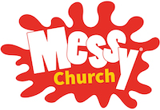
We were not able to meet monthly in the Parish Hall from 3-4.30pm on the second Sunday afternoon in each month for the first half of the year during the Covid 19 lockdowns
However, we kept the monthly gatherings going. Zoom recordings were made which included one of the families and these were put onto the Harnham Parish YouTube channel for anyone to watch who had access to a computer. This was backed up each month with activity bags delivered to 17 families so that they could join in with what they were watching on their screen.
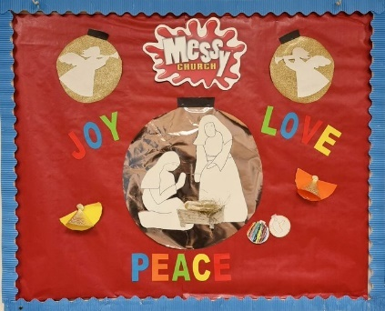
Diocese and government guidance were followed when restrictions started to be lifted and we could meet in person again – first outdoors and then indoors with families staying in their own groups and only interacting with others from a distance. The internet advertising was very effective, and this continued using social media as well to keep in touch with interested families.
Like all church services, we never know how many families will arrive which can be interesting when preparing for the afternoon. We provided a tea but our team for this has greatly diminished and we need more offers of help to make it sustainable.
Celebrations for families include games; crafts; songs, prayers, and activities.
With a lot of prayer in the parish the recent and future baptisms seem to have boosted the number of families at Messy Church.
EVERYONE is welcome to join in with this way of exploring the bible and praising Jesus through fun, laughter, and joy, in a relaxed and sharing way.
We are now registered on the main Messy Church website, where anyone interested can find us in the directory.
If you would like to know more, please talk to Jean Mercer, or Penny Joyce who leads the celebration and prayers.
Jean Mercer
---------------------------------------------------------------------------------------------------------------------------------------------------------
POP UP YOUTH
After a consistent attendance of 12 before the pandemic, we were very much hoping to rebuild the links with Pop Up Youth in 2021. However, we did not meet this year. Some of the Pop Up Youth group attended the Nativity services. The fact is that Covid restrictions, hall renovations and most volunteers having many hats has meant it wasn’t possible to meet! Revd Becky heads up the team who run the group - some are teachers or other workers who need to stay well for their professional roles or are involved in the hall renovations. This highlights how much we need to gather people with a desire to see young people thrive in Harnham. We aim to return in the autumn 2022.
Revd Becky Roberts
-----------------------------------------------------------------------------------------------------------------------------------------------------------


For the first 7 months of the year our branch members continued to support one another and meet via Zoom where we welcomed interesting and challenging speakers.
By September we were able to return to comparative normality and celebrated with our Soup and Sweets lunch in aid of Overseas work.
Revd Mike Badger led a spirited discussion on rewriting the 10 commandments for the 21st century in October and in November we experienced Messy Church for adults! The year closed with our Christmas Service taken by Canon Michael Goater and the knowledge that our completed Altar kneelers for St George’s would be blessed and put into use in January.
Katharine Callard
--------------------------------------------------------------------------------------------------------------------------------------------------------

PAUSE FOR PROSECCO
Meets monthly on a Thursday evening between 7.30 and 9pm. We are a group where big questions are asked and mulled over with a range of views - we listen and learn from one another. We also look out for each other.
We continued to meet monthly during the various lockdowns via zoom and in gardens with an attendance of between 10 and 12 ladies. Meeting as a group has been a support and a joyful release with lots of serious ideas and a lot of laughter.
Discussions have included Celtic Christianity - a church without walls, finding God in the simple tasks of life and in creation; Past, present and future - youth, adulthood and death! Songs that sustain us; favourite books that inspire and challenge us; war and peace; How can we live out our faith - is it faith or good works that makes us Christian? And a Christmas social.
We are an open group and new members are welcome.
Revd Becky Roberts
----------------------------------------------------------------------------------------------------------------------------------------------------------
Committee Members:
Joanna Woodd, Olivia Thomson,
Robert Salkeld
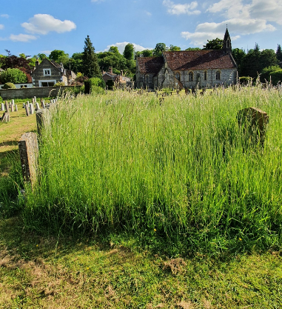
ECO CHURCH REPORT

Pray
During the year a small group of us managed to meet once, but I apologise that we have not met more often and take full responsibility for this failure. However, there has been good communication between the group’s members and numerous conversations with people from the community as and when they visit the churchyards. We have listened to God, through both church members, friends and those who have loved ones buried in the churchyards; and we are aware that we still don’t have the balance right with the wilding and the more pristine areas of the land. Churchyards are sanctified places where we can bury our dead, and obviously there are strong emotions involved; but they can also be places for the living, such as our smaller brothers and sisters, the bees and dragonflies to name two members of creation. The question remains as to who we are serving as a church, is it the dead, living church members and/or God’s creation of wild flowers and smaller living creatures? So, we need to continue to listen to God and discern His will for us and all those who use and love our two very special churchyard spaces.
Serve
Both churches and the Parish Hall are now heated and lit with eco-friendly energy, through Octopus, thus reducing our carbon footprint. The Parish completed for the first time the Church of England’s Energy Footprint Tool, which enables us to gauge our carbon emissions. It will be interesting to see if we have managed to reduce our emissions compared to the previous year, and we will need to discuss how we continue to reduce year on year, in order to reach a target of net zero. We held a stall during the Pet Festival and children along with their parents were glad to take bird seed away for their feeders at home. We have continued to have articles in the parish magazine, with either information about sightings of certain bees and flowers, also encouraging readers to measure their own carbon footprints. There are plans to plant some trees, both for ecological reasons and to celebrate the Queen’s Platinum Jubilee.
Grow
There were some interesting and lively emails debating the cleaning of silver and brass in an eco-friendly manner; this proved to be somewhat difficult, especially when it comes to the size of the cross. But it demonstrates our commitment to using eco-friendly cleaning products. In September we were invited by our Roman Catholic friends to participate in a Creation-tide walk of ‘stations’ which would start in the Cathedral Close and finish at St George’s, as they appreciated the ‘living churchyard.’ A number of residents from Buttercup Close have had swift boxes installed to give safe homes, like the church eaves, to these brave amazing small birds. Over the year the wildflowers have flourished; at All Saints the previous year there was only one spotted orchid and this year there have been two, plus a robust pyramid orchid, and both are likely to multiply over the coming years. At St George’s we have been pleased to see the wild Clary, a type of sage, appearing all on its own. Also, you may have enjoyed the nodding bells of the harebells in the summer breezes, which are also attractive to all kinds of insects. Both churchyards have become ‘living’ with the amount of wildlife which has appeared. Three species of grasshoppers have been seen and heard, countless froglets, enjoying the longer grass, an interesting bee ‘Andrena Hattorfiana’, which visited the churchyard because of the scabious, which are the only flowers from which it can collect pollen and nectar.
Albert Schweitzer wrote: “Until we extend our circle of compassion to all living things humanity will not find peace”
Let us strive for peace for the whole of creation.

ECO CHURCH REWARD SCHEME
 | St George’s | All Saints
WORSHIP | Gold | Gold
BUILDINGS | Silver | Silver
LAND | Gold | Gold
COMMUNITY & GLOBAL ENGAGEMENT | Silver | Silver
LIFESTYLE | Silver | Silver

Joanna Woodd
--------------------------------------------------------------------------------------------------------------------------------------------------------
Committee Members:
Pam Macklin, Robert Salkeld,
Anne Paterson, Josa Snow and
Ayesha Nickol.

SOCIAL REPORT
Despite restrictions due to the pandemic several events were held, observing sensible precautions and safety measures.
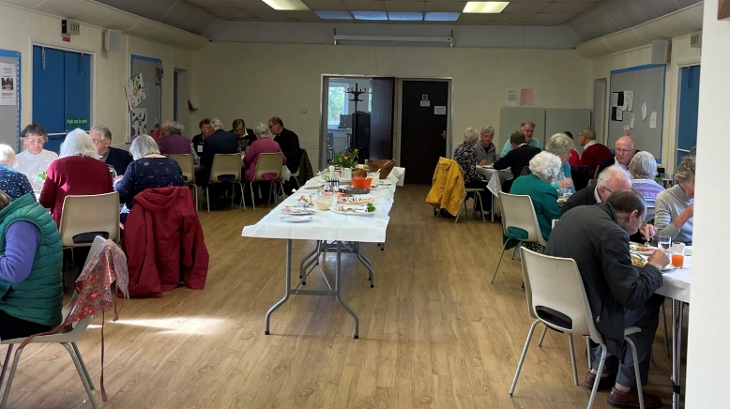
- Great Day Out -we served hot and cold drinks together with cakes and biscuits. Disposable cups and individual cartons of juice were used, and all biscuits and cakes were commercial produced and individually wrapped. Ice creams and lolly ices proved a great hit as the weather was on our side.Pet Festival – drinks, cakes and ices were served as for GDO.
- Harvest Lunch – About 40 attendees were served a cold buffet. There was no licence for wine so only water and soft drinks were available. Harvest Lunch

- AS Patronal – the usual outside caterers were not available so the format and venue were changed. A cheese and wine lunch was held in the parish hall. Illness prevented one or two attendees on the day but overall this was a success. The food was on each table to minimise handling. Various members of the congregation were approached to provide deserts. These were offered as table service. Some remaining cheese was offered to the Women’s Refuge where it was willingly accepted.
The Social Committee were unable to offer refreshments for the Carol Service as too many of them were already away for Christmas.
Pam thanks the Committee for all their support together with those who step up ad hoc to help with setting up tables etc and to all those who come and enjoy events.
Pam Macklin
--------------------------------------------------------------------------------------------------------------------------------------------------------
COMMUNICATIONS COMMITTEE
Committee Members:
Revd Becky, Revd Julian, Charles Woodd, Linda Baker, Ian Davidson, David Stone, Olivia Thomson, Matthew Stone

Pray
A major preoccupation this year has been the development of our use of technology, both to support outside services in the Parish Hall field, and to live stream and record and upload to YouTube a range of regular and occasional services and talks, so as to reach a wider audience. During the year, the Parish purchased mobile public address equipment for use outside, after relying on Revd Julian’s generosity in loaning and operating his own equipment from early in the pandemic. The Parish has also relied very heavily on Revd Julian’s good offices to live stream and record services. This has proved particularly popular for weddings and funerals, where Covid restrictions have prevented people from attending in person, and for regular services where people have been prevented from attending due to lack of mobility, or anxiety about Covid. In the light of this experience, the Committee considered a number of options for the purchase of new audio visual equipment for All Saints church, and the PCC agreed to the use of legacy gifts to finance the purchase of a complete new audio visual system for the church, as well as a portable system that can be used in St George’s and elsewhere. Installation of the equipment in All Saints is now only waiting for the successful receipt of a Faculty from the Diocese.
Following the practice stimulated by the 2020 lockdown of uploading services to the Parish YouTube channel, throughout 2021 12 services and talks were recorded and added to the channel, attracting from 24 to 80 views each.
Serve
The Parish Magazine has continued to be produced each month, and delivered door-to-door whenever restrictions allowed, thanks to our long-standing and loyal team of distributors. We are very grateful to Pam Ashley, who now manages the distribution of the Magazine, Ian Davidson who continues to edit it so faithfully, Simon Jackson who secures our advertisers, and the loyal team of volunteers who meet every month to collate it.
I am very grateful to my fellow Committee members, thanking particularly Matthew Stone who is stepping down to give priority to his work as an LLM in the Parish, and Olivia Thomson, who operates the Parish twitter handle very actively and consistently, has also acted as minutes secretary and who also has regularly operated the PA equipment for services outside.
Grow
The Committee has looked carefully at what steps could be taken to publicise Parish activities and events more widely and effectively. A protocol for organising groups to follow was agreed in 2020, but the Covid limits on in person events prevented its use in practice. It has now been simplified, and will be circulated to all Parish event organisers. The Committee identified the need for a Parish Facebook page, and a more comprehensive and active use of social media and the Parish website, but recognised the urgent need for a knowledgeable volunteer to spearhead such a development. That vacancy has not yet been filled. The Committee also recognised the need to ensure the Parish page on the Church of England’s ‘A Church Near You’ site is kept up to date, for which a dedicated volunteer is also needed.
Work commenced during the year on a new Welcome and Information Pack for new church members, and this should be available in hard copy and on the website in early 2022.
Following the earlier installation of new noticeboards at St George’s and the Parish Hall, the matching new noticeboard was finally able to be erected at All Saints.
Charles Woodd
-----------------------------------------------------------------------------------------------------------------------------------------------------------
SOCIAL MEDIA
Parish Website: www.harnhamparish.org.uk
Twitter: @HarnhamParish
 Facebook @HarnhamParishCommunity

The social media in Harnham parish is overseen by the Communications Committee. We have explored various types of social media and consistently use our YouTube channel; however we have had difficulty creating and maintaining an active Harnham Parish Churches Facebook account, as it needs to be run from an individual person’s account and can't be created like a business account. This and other social media platforms have been discussed in further detail by the Communications Committee. The Parish Twitter account is the most active social media we use with good levels of engagement and reach. It is essentially a microblogging site where users can post short amounts of text, photos and videos. These “tweets” are interacted with by other users interested in the same topics. When Olivia took over running the Twitter account, she sought agreement from the PCC to sign up to the Church of England Digital Charter which can be found online and aims to make social media a more positive place, always considering truth, kindness, welcome, inspiration as witnesses of our faith, togetherness, safeguarding and agreement.
Pray
We share our Christian faith via the Twitter account at several different levels such as retweeting the Church of England prayer for the day, plus numerous other aspects of faith locally in the parish, in Salisbury, in Wiltshire, in the diocese, nationally and even globally. We include prayer themes throughout the liturgical calendar and also focus on posting and sharing topics we support in the parish and diocese such as the Sudan link, Eco Church, Christian charities, and national DEC appeals, along with other key areas of our parish life such as Mothers’ Union, Messy Church, social events, fundraising activities, and our regular Sunday service patterns. We also share regular posts from the Archbishops, the Church of England, our Bishops, Dean, Archdeacon, Cathedral, and our clergy.
Serve
Our immediate location to serve via Twitter is Harnham and Sarum deanery. We regularly widen our content to cover the county and the whole diocese. This is often by sharing local events, activities particularly for vulnerable groups, public service announcements such as problems with buses or issues at the hospital, Salisbury Journal, radio stations, council notices, police and fire service appeals and of course NHS and Public Health England info over the last two years. We share and interact with other groups in Harnham such as the Social Club, the Community Network, the Bunker, occasional school posts and other active local accounts. This has built up a common sharing of each other’s services, events and activities which was particularly useful during the lockdowns when many of these took place via zoom and provided a vital connection to others. We frequently share links to our YouTube channel and notify when public services and talks are available. We post photographs of events and of both churches when appropriate and with permission, always keeping safeguarding in mind. We post using GIFs to gain users attentions, as research has shown that posts using a short moving image get more interaction than plain text. We have good links with the Diocesan communications team and are known for having an active presence online. We also share topics of interest, images, activities, courses, and events linked to various religions, arts, music, and theology. Although it is a lot more than just sharing our service times and events, we have posted short notice changes of location to services which has then been seen in time on Twitter to enable people to attend services in the right place.

Grow
The number of followers on our account has steadily increased and is currently 467, although this is a fluid number with natural ebbs and flows. Twitter enables users to see content that other individual accounts have liked. This is where a lot of our following has built up from the Anglican community in the UK and the charity sector. We also participate in “Salisbury hour”, which is one hour a week where anything Salisbury related can be posted using the hashtag, it will then be shared and discussed widely. Although this is currently on a hiatus, we have built up good relationships with local businesses, charities, organisations, and individuals through this who perhaps would not usually follow a church account. Our regular supportive posts for local and national charities, whether by sharing financial links for appeals or by prayer, has also gained us further reach with some comments noting that they were pleasantly surprised to see a church involved in such matters e.g. environment and climate crisis, collections for specific local causes such as the Women’s Refuge, Foodbank and occasional political campaigns, with permission from Rev’d Becky, such as supporting the free school meals campaign from the previous year. The account receives queries regarding local parish activities and events, and we are pleased that Harnham Community Network has recently created their own account who we enjoy sharing posts with, particularly the HarvestTable in the summer. Under the Communication Committee we continue to develop and consider the use of social media in the Parish and reflect on how we may grow further and develop this account and potentially others, in the correct manner under the digital charter to communicate how we live, learn and love Christ in Harnham.
Olivia Thomson
-----------------------------------------------------------------------------------------------------------------------------------------------------------
SAFEGUARDING REPORT
The Diocesan microsite is a wonderful tool and keeps everything up to date. DBS‘s are automatically submitted for renewal. The continued uncertainty of face to face interaction through the pandemic has prevented anyone needing help with C0 or C1 to complete the online course. Nor were there any face to face meetings between the Vicar and the Safeguarding Officer. Emails, however, have been exchanged as necessary. Electoral roll members should be aware that abuse issues have been an ongoing concern within the parish, during the pandemic restrictions. These remain confidential.
As usual the PSO would also like to express her thanks to the Diocesan Safeguarding Team based in Church House for their support and prompt replies to queries.
Pam Macklin, Parish Safeguarding Officer
------------------------------------------------------------------------------------------------------------------------------------------------------------
FINANCE WORKING GROUP
Finance Working Group:
David Curzon, Michael Fisher, Kate Mash, Rev Becky Roberts, Charles Woodd

Pray, Serve and Grow
During the year, the Group reviewed the PCC’s approach to fundraising, with a view to developing a Fundraising Strategy for the Parish, drawing on the guidance produced by the Church of England, ‘Building a Generous Church.’ A number of recommendations were put to and approved by the PCC, leading to the following actions during the year:
- The importance of demonstrating the IMPACT achieved with donations to the Parish was highlighted. This was reflected in literature supporting the autumn Stewardship Appeal. The Parish urgently requires a volunteer with marketing and PR experience to assist in this field.
- The importance of offering a range of mechanisms through which people can give to the Parish was recognised. This is being implemented by:
- the creation of online donation pages for special appeals on www.stewardship.org.uk;
- the creation of a Welcome and Information Pack for new church members (to be available early in 2022)
- a proposal to trial contactless giving has still to be put into effect.
- The importance of ensuring that donors are personally and regularly thanked was reaffirmed, and has been put into action.
- The vital importance of Planned Giving was reiterated, and particularly through the Parish Giving Scheme, which reduces the administrative burden on Parish volunteers. A Stewardship Campaign to boost planned giving was launched at Harvest Festival, which resulted in an annual net increase in regular giving of over £1600. Further one-off donations were made totalling £800 at the end of the year.
- The loyal and generous support of the Friends of Harnham Churches was recognised, and it was decided to seek an Honorary Secretary for the Friends, to take steps to promote the Friends and increase membership. Anyone interested in taking up this position is invited to contact Charles Woodd.
Covid restrictions had an obvious impact on the practicality of live fundraising events. However a number of events were able to take place during the year. These included the Great Day Out in July, shortly after Covid restrictions were for the time being lifted, which drew hundreds of people to the Parish Hall field for a day of family activity, enabled the launch of the Harnham Hub Appeal, and raised nearly £2,500 for the Appeal. Five Musical Evenings in St George’s Church in the summer raised £1,054 for the Parish. In September, the Pet Festival drew animal lovers and their pets to the field, and also raised £905 for the Parish.
The PCC is grateful to all who support our various fundraising activities as loyal volunteers, but particularly acknowledges the quiet but dedicated and vital work of David Curzon as our Planned Giving Secretary.
Charles Woodd
----------------------------------------------------------------------------------------------------------------------------------------------------------
CHURCH LINKS
Pray, Serve and Grow
Covid inevitably limited the activity of Church Links for much of the year. However, it was possible for all our Church Links to join with volunteers from Harnham Community Network (HCN) to distribute an HCN Newsletter and a Harnham Hub appeal brochure to every household in the Parish in July. Furthermore Links continued to deliver Welcome Packs to new residents, and cards to neighbours in the Parish celebrating the anniversary of their baptism, wedding or bereavement.
A major development took place during the year. After careful debate amongst the Church Links themselves, the PCC and the Harnham Community Network agreed that the Network would take over formal responsibility for seeking to welcome new residents to Harnham, and as part of this would assume responsibility for editing and publishing the Welcome to Harnham Pack. We are grateful to Roger Treleaven, HCN’s Treasurer, and a group of Network volunteers for taking this on. At the end of the year, work on preparing the new Welcome Pack was making good progress. Church Links will continue to deliver it in their roads, alongside additional Community Links to be recruited from amongst the Network’s members.
Charles Woodd, Church Links Coordinator
---------------------------------------------------------------------------------------------------------------------------------------------------------
DEANERY SYNOD
The Deanery Synod met twice during 2021 in June and November. Membership from Harnham includes Neil Turpin, Katy Carter and clergy.
Richard Chitty stepped down as lay chair and secretary. Ted Uren has taken up the post of lay chair.
There has been an ongoing draft deanery plan discussed over these meetings that continues the plan from 2019
a. Mission - focusing on ensuring we maintain or establish a Christian presence in all our schools, housing estates and care homes.
b. Community - focusing on engagement with the civic authorities and other charities working throughout Salisbury.
c. Occasional Offices - focusing on offering Christian weddings and funerals as an alternative to civil ceremonies
d. South Sudan - focusing on developing our relationship with Juba Diocese.
e. Discipleship - focusing on supporting both adults and young people in developing their faith.
Dates of future meetings were set out as Tuesday 15 February (cancelled without notice), 18 May 2022, 15 September 2022, 8 November 2022.
--------------------------------------------------------------------------------------------------------------------------------------------------------
DIOCESAN SYNOD
Revd Julian and Revd Becky have been elected onto Diocesan Synod.
Bishop Karen has chaired Deanery synod in the absence of a Bishop of Salisbury.
The foci of synod has been
- revising Parish Share in the light of the Diocesan budget,
- the revision of parish work in the light of covid; the reduction of attendance across the diocese; the reduction in staffing in Church House, reduction in paid clergy, and an emphasis on self-supporting and pioneering ministries
- the C of E need to be simpler, bolder and humbler with an emphasis on a ‘can do’ attitude.
In November 2021 Bishop Karen aptly noted the work of clergy, the need for revision of the budget and fairer share and the need for mission. “...whilst I know most people here would like to see clergy out and about most of the time, you need to understand the reality today is that God’s work is also being done inside, in meetings, in dealing with emails and preparing services, in private study, putting together teaching materials and dealing with funeral directors, stonemasons and wedding preparation. These are also tasks of the parish priest, whose calling is to be prepared within and without.”
“ the mission of the Celtic Christians to evangelise Britain supported it financially and practically. In a Synod where the budget was the main item that was a challenge to us as a diocese. Do we believe in the mission that God has given us to go into all the world and make disciples?”
2022 Foci so far
- Feedback on the proposals for Parish Share revision
- Feedback on Deanery plans
- Climate change and Eco Church
- The Archbishops’ Anti-Racism Taskforce published report ‘From Lament to Action’ and the effect racism has locally, especially on the Roma and traveller communities.
Summaries of Diocesan Synod meetings can be found on GRAPEVINE.

